Trial 3 RGB Growth-Rate and Treatment Comparison Report
This report summarises the Trial 3 RGB visible-emergence and green-cover analysis. The purpose of this script was to convert the cell-level outputs from Script 04 into tray-level and treatment-level growth comparisons. The report also documents the generated charts, CSV files, Excel sheets, and interpretation notes for final internship reporting.
The results are based on visible seedling evidence detected from RGB images. They should be interpreted as visible emergence and image-derived green-cover measurements, not direct biological germination below the soil surface.

1. Data processed
The analysis used 12 trays, with 70 cells per tray. The adjusted cell table contained 5880 cell-day records. The corrected observation period was Day 1 (29/06/2026) to Day 7 (07/07/2026). A total of 198 Day 7 cell records were flagged for adjusted estimation.
Observed Day 7 values were preserved exactly. Adjusted Day 7 values were created separately only where a cell had visible green evidence before Day 7 but was missing on Day 7.

2. Tray-level performance
The highest adjusted RGB performance score was recorded by Tray 1 (No Microbes | Ideal | Inside). Its adjusted RGB score was 97.58.
Tray | Microbe Status | Treatment | Environment Group | Final Tracked Emergence Percent | Final Adjusted Green Cover Percent | Day7 Imputed Cells | Overall Adjusted Rgb Score | Overall Adjusted Rgb Rank
Tray 1 | No Microbes | Ideal | Inside | 100.0 | 8.156 | 60 | 97.584 | 1
Tray 5 | Microbes | Moisture | Inside | 100.0 | 6.621 | 45 | 81.613 | 2
Tray 8 | Microbes | Heat | Dynamic Heat | 100.0 | 6.423 | 8 | 75.812 | 3
Tray 6 | Microbes | Heat | Dynamic Heat | 97.143 | 7.16 | 0 | 73.378 | 4
Tray 12 | No Microbes | Moisture | Inside | 98.571 | 6.422 | 9 | 66.785 | 5
Tray 4 | No Microbes | Heat | Dynamic Heat | 100.0 | 4.791 | 18 | 66.118 | 6
Tray 11 | No Microbes | Heat | Dynamic Heat | 98.571 | 3.975 | 18 | 56.962 | 7
Tray 7 | Microbes | Ideal | Outside | 97.143 | 6.464 | 2 | 55.289 | 8
Tray 9 | Microbes | Ideal | Inside | 95.714 | 4.045 | 36 | 35.112 | 9
Tray 3 | No Microbes | Moisture | Outside | 95.714 | 3.635 | 2 | 30.5 | 10
Tray 2 | No Microbes | Ideal | Outside | 92.857 | 4.027 | 0 | 26.153 | 11
Tray 10 | Microbes | Moisture | Outside | 95.714 | 3.09 | 0 | 18.909 | 12
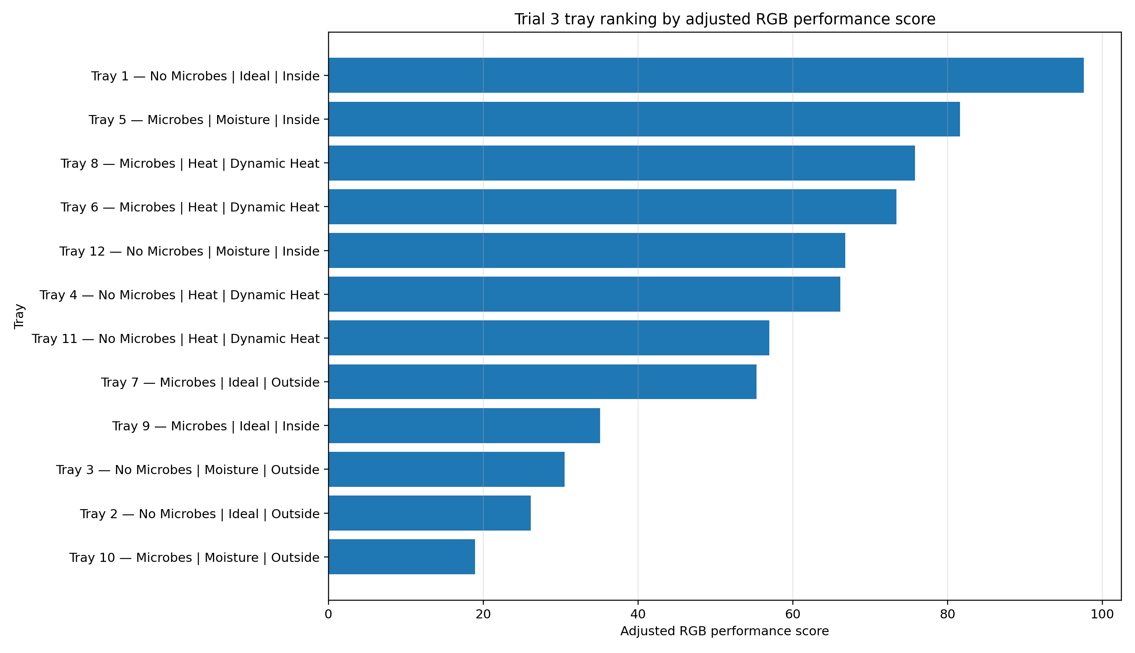

3. Microbes vs No Microbes
For final adjusted RGB green-cover, the highest mean value in the microbe status comparison was recorded by Microbes (5.63).
For overall adjusted RGB performance score, the highest mean value in the microbe status comparison was recorded by No Microbes (57.35).
Group | Tray Count | Mean Final Tracked Emergence Percent | Mean Final Adjusted Green Cover Percent | Mean Adjusted Green Cover Rate Day1 To Final Pp Per Day | Mean Overall Adjusted Rgb Score
Microbes | 6 | 97.619 | 5.634 | 0.704 | 56.686
No Microbes | 6 | 97.619 | 5.168 | 0.646 | 57.35
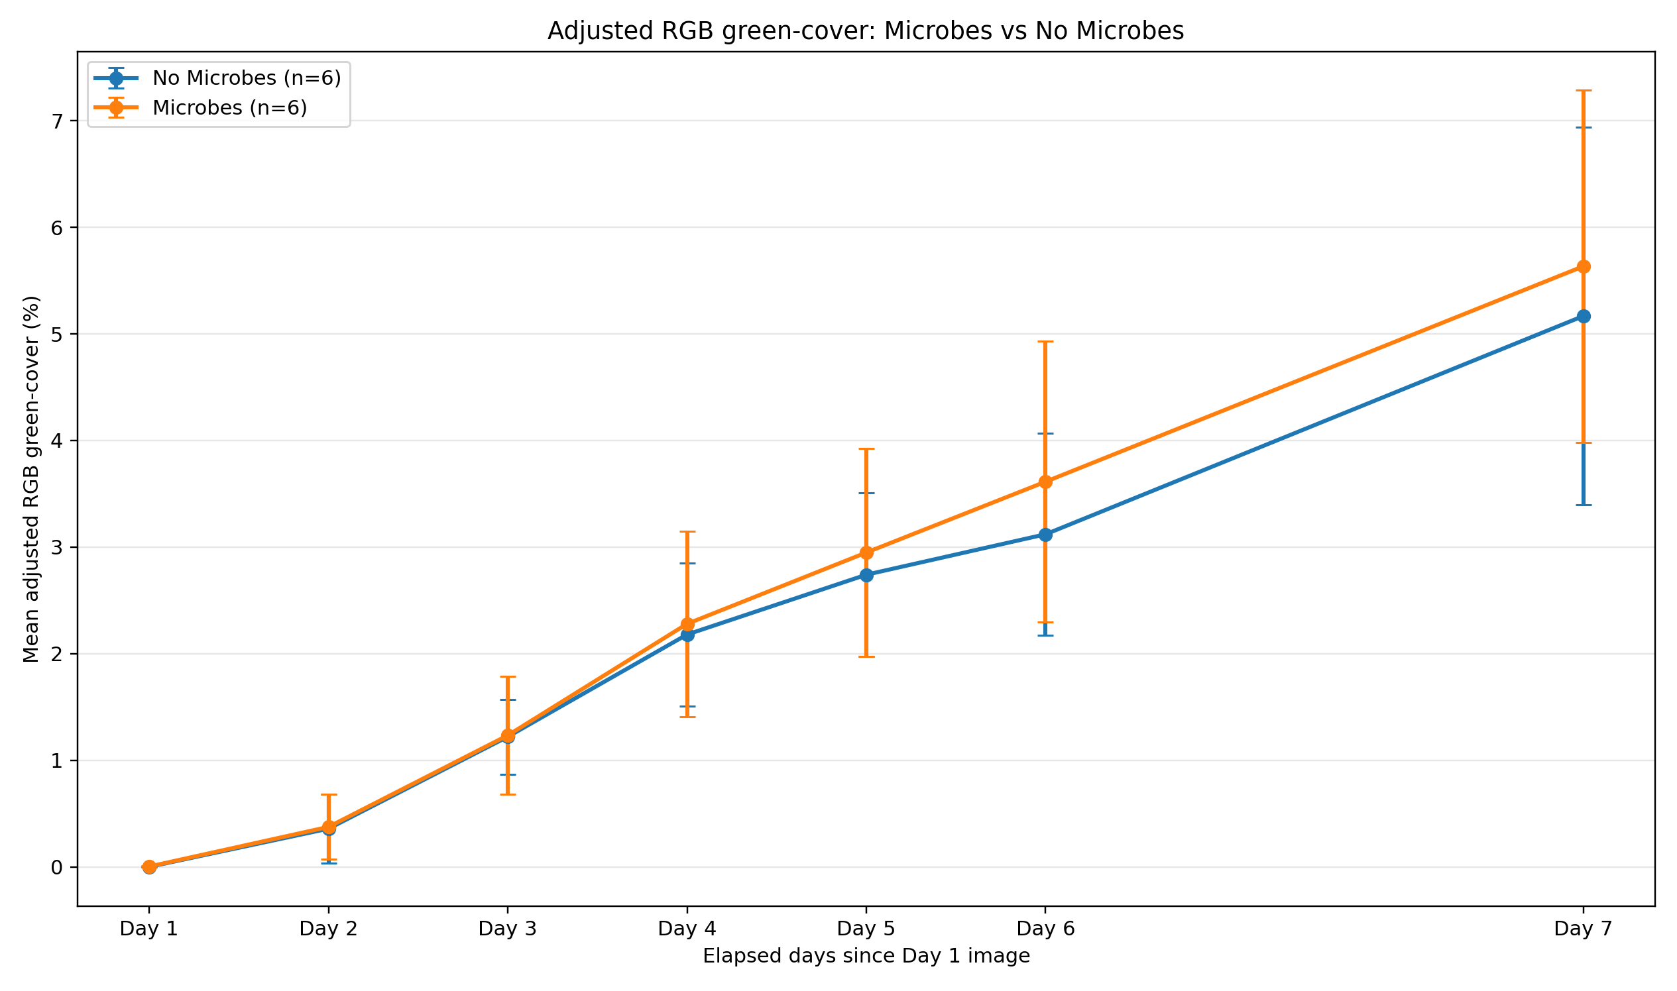
The Microbes vs No Microbes trend chart shows how adjusted RGB green-cover changed across observation days for both groups.

4. Ideal vs Heat vs Moisture
For final adjusted RGB green-cover, the highest mean value in the treatment type comparison was recorded by Ideal (5.67).
For overall adjusted RGB performance score, the highest mean value in the treatment type comparison was recorded by Heat (68.07).
Group | Tray Count | Mean Final Tracked Emergence Percent | Mean Final Adjusted Green Cover Percent | Mean Adjusted Green Cover Rate Day1 To Final Pp Per Day | Mean Overall Adjusted Rgb Score
Heat | 4 | 98.929 | 5.587 | 0.698 | 68.067
Ideal | 4 | 96.429 | 5.673 | 0.708 | 53.534
Moisture | 4 | 97.5 | 4.942 | 0.618 | 49.452
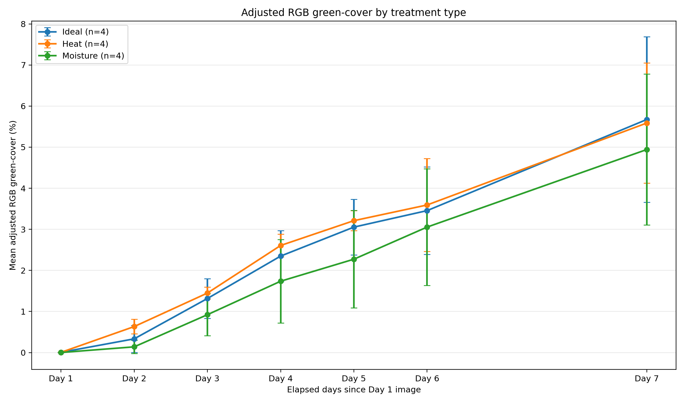

5. Ideal and Moisture Inside vs Outside comparison
This section directly compares fixed Inside and fixed Outside trays for Ideal and Moisture treatments. Heat trays are excluded because they were moved between environments during the trial.
Treatment | Inside Tray Count | Outside Tray Count | Inside Trays | Outside Trays | Inside Final Emergence Percent | Outside Final Emergence Percent | Inside Minus Outside Final Emergence Pp | Inside Final Adjusted Green Cover Percent | Outside Final Adjusted Green Cover Percent | Inside Minus Outside Adjusted Green Cover Pp | Inside Minus Outside Adjusted Growth Rate Pp Per Day | Interpretation
Ideal | 2 | 2 | Tray 1, Tray 9 | Tray 7, Tray 2 | 97.857 | 95.0 | 2.857 | 6.101 | 5.245 | 0.855 | 0.106 | Inside performed higher than Outside for adjusted Day 7 RGB green-cover.
Moisture | 2 | 2 | Tray 5, Tray 12 | Tray 3, Tray 10 | 99.286 | 95.714 | 3.571 | 6.521 | 3.363 | 3.158 | 0.395 | Inside performed higher than Outside for adjusted Day 7 RGB green-cover.
For Ideal trays, the inside-minus-outside difference in adjusted final RGB green-cover was 0.86 percentage points. Interpretation: Inside performed higher than Outside for adjusted Day 7 RGB green-cover.
For Moisture trays, the inside-minus-outside difference in adjusted final RGB green-cover was 3.16 percentage points. Interpretation: Inside performed higher than Outside for adjusted Day 7 RGB green-cover.
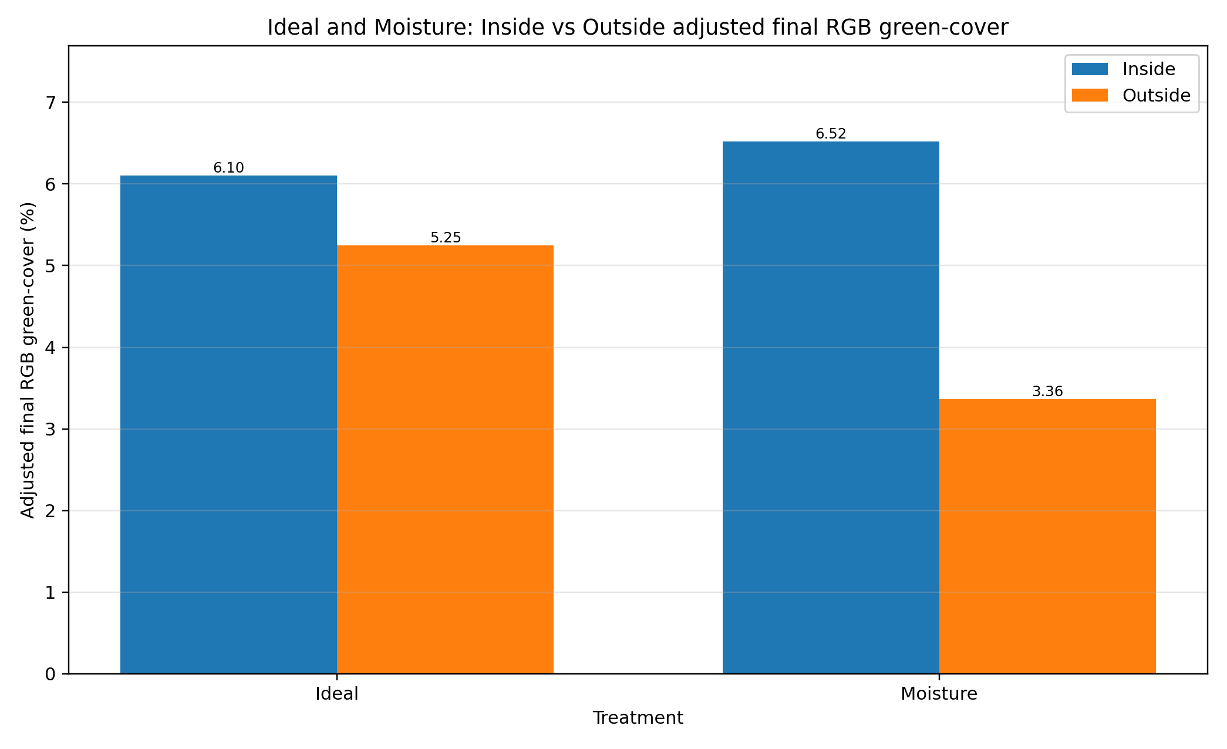
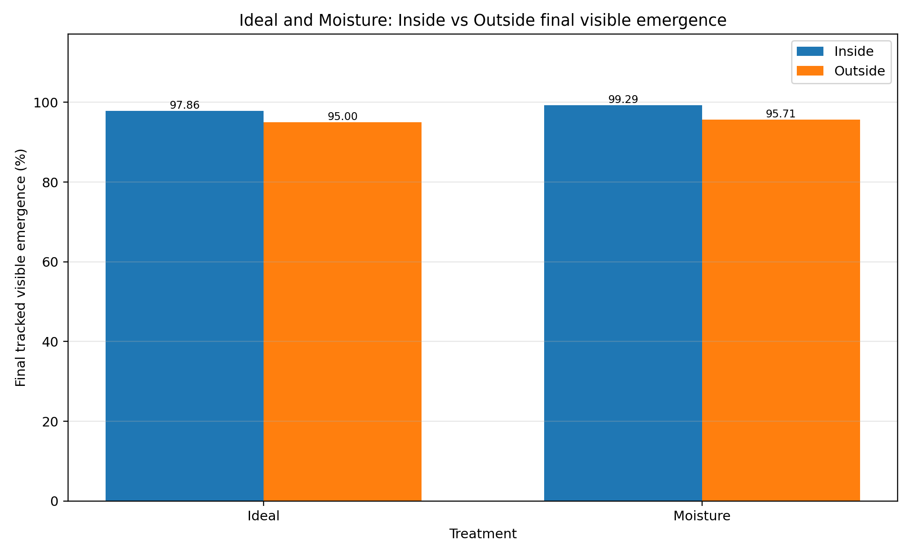
The Inside vs Outside green-cover chart compares final adjusted green-cover. The emergence chart compares final tracked visible emergence. These are different because emergence measures how many cells had visible seedlings, while green-cover measures the amount of green plant area within cell zones.

6. Observed vs adjusted Day 7
Observed Day 7 results represent what was visible in the final images. Adjusted Day 7 values are a separate scenario created for growth-rate comparison when a cell had earlier crop evidence but no visible green evidence on Day 7.
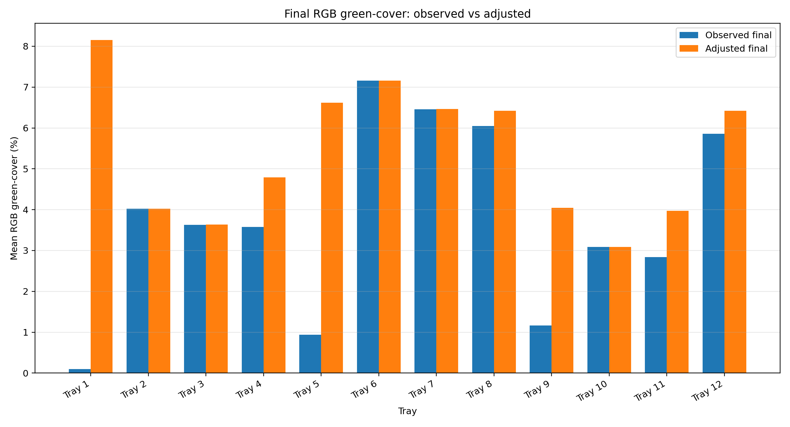
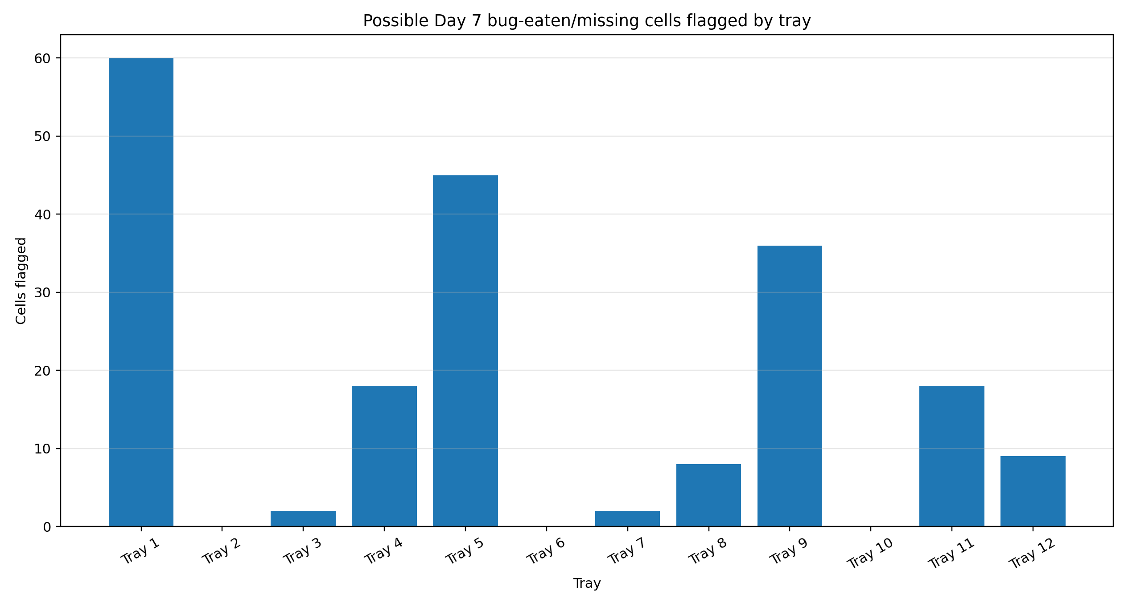

7. Description of generated CSV files
cell_growth_with_day7_adjustment.csv: Full cell-level dataset after Day 7 adjustment processing. It preserves observed values and adds adjusted green-cover columns and imputation flags.
tray_daily_rgb_metrics.csv: Tray-by-day summary containing daily visible emergence, observed green-cover, adjusted green-cover, newly emerged cells, and Day 7 imputed cell counts.
tray_growth_metrics.csv: Tray-level growth summary containing final emergence, final observed and adjusted green-cover, growth rates, T50 timing, and RGB performance scores.
group_daily_metrics.csv: Group-by-day table used for trend charts across Microbes, treatments, and environment combinations.
group_growth_metrics.csv: Final group-level comparison table for treatment and environment groups.
inside_outside_comparison_ideal_moisture.csv: Dedicated Ideal and Moisture Inside vs Outside comparison table.
environment_metadata_debug.csv: Debug table showing each tray's standardised treatment and fixed environment assignment.
possible_day7_bug_eaten_cells.csv: Filtered table of cells where adjusted Day 7 values were estimated.
heat_phase_response.csv: Descriptive summary of Heat tray performance across movement phases.
moisture_phase_response.csv: Descriptive summary of Moisture tray performance across watering and dry phases.

8. Description of Excel workbook
The Excel workbook rgb_growth_treatment_report.xlsx combines the main CSV outputs into one inspection file. The most important sheets are Tray Growth Metrics, Group Growth Metrics, Inside Outside Compare, Day7 Imputed Cells, and Environment Debug.

9. Description of generated charts
01_microbes_visible_emergence_trend.png: Tracked visible emergence trend for Microbes and No Microbes.
02_microbes_adjusted_green_cover_trend.png: Adjusted RGB green-cover trend for Microbes and No Microbes.
03_treatment_visible_emergence_trend.png: Tracked visible emergence trend for Ideal, Heat, and Moisture.
04_treatment_adjusted_green_cover_trend.png: Adjusted RGB green-cover trend for Ideal, Heat, and Moisture.
05_day7_observed_vs_adjusted_green_cover_by_tray.png: Observed vs adjusted final green-cover for each tray.
06_adjusted_rgb_tray_ranking.png: Tray ranking by adjusted RGB performance score.
07_day7_possible_bug_eaten_cells_by_tray.png: Number of possible Day 7 missing or bug-eaten cells by tray.
08_inside_outside_adjusted_green_cover_ideal_moisture.png: Inside vs Outside adjusted final green-cover for Ideal and Moisture trays.
09_inside_outside_emergence_ideal_moisture.png: Inside vs Outside final visible emergence for Ideal and Moisture trays.

10. Interpretation and limitations
These results are suitable for identifying treatment trends, but they are descriptive image-derived results, not formal statistical proof. Lighting, image quality, green-pixel thresholding, crop overlap, and cell visibility can affect RGB green-cover estimates.
The Day 7 adjustment should be used only for adjusted growth-rate comparison. Observed Day 7 values should remain the source for reporting what was actually visible in the images.
The Inside vs Outside comparison is restricted to Ideal and Moisture trays. Heat trays are excluded because they were moved between environments. Later multispectral scripts should be used to check whether NDVI and NDRE support the RGB findings.

